Slaying Dragons
Strategy Plan Template



2017-2020 Strategy Plan

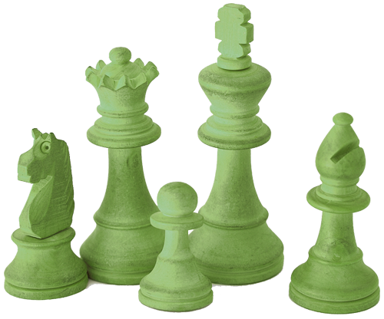

QUESTION TO BE ANSWERED | STRATEGIC PLAN ELEMENT
Where we were in the past? | History
Where are we now? | Context
Where should we go and why? | Vision
What is our work toward the vision? Who are we? What is our niche now to work toward the vision? | Mission

QUESTION TO BE ANSWERED | STRATEGIC PLAN ELEMENT
What will guide the work we choose to do and the way we do the work (e.g. inclusively, multi-disciplinarily?) | Values
What is in our way of realizing our vision? | Critical Obstacles
What will we do to reach our vision? | Strategic, Long-term Goals/Directions
What will we do in year 1, year 2 and so on? | Short-term Goals or Objectives
How will we know if we are successful? | Indicators of Success/ Benchmarks

QUESTION TO BE ANSWERED | STRATEGIC PLAN ELEMENT
What infrastructure is needed to carry out the work in this plan? | Infrastructure Assessment
What will we do in the next 3 months, six months, year, year 2, and year 3? | Implementation Plan
How will the plan be disseminated and to whom? | Dissemination Plan  Implementation Plan
How will we monitor the plan and assess our progress? | Monitoring and Revising Strategic Plan

